Miniture Hyperloop Prototype  
Project Proposal -FInal Year Project

M.L. Hariras Tongyai

# Overview

## Project Background and Description

The Hyperloop: The fifth mode of transportation is an open-source idea prop ose by the futurist Elon Musk as an alternative mode of transportation to the California High Speed rail project which does not offers any innovative ideas along with indifferences in terms of reduction of both travel time, cost and efficiency. The Hyperloop will between Los Angeles and San Francisco in only 30 minutes with a total estimation of 840 passengers per hour (28 passengers every 30 seconds).

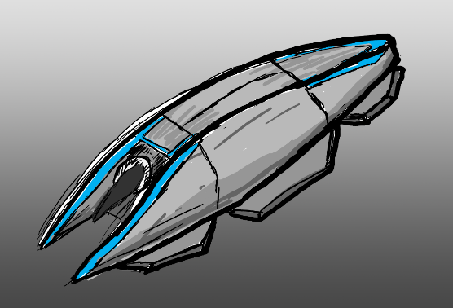

**Hyperloop Pod Concept Sketch Figure .1**

My fascination with the Hyperloop concept is the use of simplistic systems to implement an innovative solution of channeling air resistance and pressure through the hyper loop pod to achieve an aircushion lift and proportion to minimize friction and resistance in motion within a low pressure or near vacuum tubing. (For Technical approach refer to the “Approach taken section”). The Hyperloop pod is a self-contained pod which handles levitation and propulsion with a single air compression system and will be the main focus of the proposing project.

As an open-source idea, many organizations, private companies, government agencies, universities and student group have formed R&D projects and competitions based on this concept which resulted in multiple variation of the Hyperloop system ranging from the use of the original concept of “Air Bearings” to the use “Electromagnetic suspension”. However, from this detailed initial research I hope to devise and implement my own approach to the Hyperloop concept and build a miniature system demonstrating the system outlined in this project proposal.

This proposal contains research from:

* Elon Musk’s Original Hyperloop Alpha’s Proposals.
* Hyperloop Pod Sizing model conceptualization by the Nasa Glen Research Team (Cleveland, OH).
* SpaceX’s Hyperloop Test-Track Specification Documentation (From Hyperloop Solutions Competition Testing) February 18, 2016.
* Hyperloop One – Progress
* Hyperloop Technologies - Progress
* Research and Development by Hyperloop Makers UPV Team – Participated in SpaceX Track Test

## Feasibility

The feasibility factor of the project will be judge by the following factors:

* Cost under £100.
* Appropriate approach.
* Self-contained design.
* Time to build no more than 4 Month.
* Demonstration Simplicity & Convenience
* Able to reflect real world applications and implications

*Detailed Documentation on the criteria available in Detailed proposal.

## Approach

The approach I will take for the different element of this project:

* 3D Printed CAPSULE with Miniature Motors & battery (Air Bearing Version)
* Wifi Enabled Microcontroller for wireless control
* 1-meter flexible tubing determining this diameter of the capsule
* Model Potential System
* Reflect and evaluate real-world use.

## Cost Estimation

After an extensive research and 3D Printing quotes from Shapeways, Ponko and Maker’s Café, depending on the complexity of the design the cost for the pod itself can be compress to under £50 as the pod will be a self-contained design leaving the result of the estimated £100 budget to:

* £10 for Motors
* £5 for battery
* £20 for Microcontroller
* £15 for a meter-long tube.

*Refer to Cost Analysis Excel sheet: Hyperloop Cost Analysis

## Extended Resources to back this proposal

Resource Collected, written, design and simulated for this project:

* 3 different CAD (.stl) Models of capsule created
* Sketch and Design for Airflow drew in 3D VR with Tilt brush to simulate the lift and propulsion
* Research on suitable components:
  + Motors
  + Tubing
  + 3D printing quote
  + alternative Manufacturing method.
* Multiple capsule Design.
* Multiple propulsion and lift system research.
  + Air Bearing
  + MagLev

## PROJECT AIMS:

*State the design, development or research challenge that the project aims to solve.*

This project aims to design an approach to the Hyperloop Alpha Proposal (open-source concept) and develop a new approach on a miniature scale exploring the feasibility, implications and factors effecting the Hyperloop system. The concept inspiration was taken from Hyperloop One and Space X’s competition for students to create and propose their own version which is the goal of this project.

The project will explore the appropriate mechanical system such as the motor system needed to achieve levitation and propulsion through either Air bearings or electromagnetic levitation develop in conjunction to a control system which should be able to regulate or control the motor system with a control panel/program communicating with the capsule via both Serial Communications and wireless communications (TCP).

At the end of the project a discussion about the real world application or reflection of the larger scale counterpart based on the developed system on the feasibility, implications, efficiency and effectiveness of the proposed Hyperloop System. A glimpse or brief introduction to indicate if the Hyperloop or any of its variation would an appropriate alternative or new mode of transportation in the future.

## METHODOLOGY:

*Describe the various steps that you intend to follow in order for you to achieve your project aims.*

1. **Research**
   1. Motor System
   2. Microcontrollers
   3. Maglev Trains
   4. Air Hockey & Hovercrafts
   5. GUI System
   6. 3D Printing Calibration & Best Practices
2. **Cost Estimation**
   1. All Components (Initial Estimation Available Refer to Hyperloop Cost Analysis spreadsheet).
3. **CAD/CAM**
   1. Blueprints/Orthographic Diagrams
   2. 3D Cad files of Capsules (Creo & .stl files)
   3. 3D Printing capsule and parts
4. **Software**
   1. **Microcontroller code**
   2. **Network (TCP Code)**
      1. Windows Software (Server)
      2. Microcontroller flashed code (Client)
5. **Hardware**
   1. **Capsule Circuits**
      1. Motors
      2. Microcontrollers
      3. Battery
   2. **Tube Stand**
   3. **Capsule Assembly**
6. **Experimentations**
   1. Capsule Subsystem
   2. Tube Subsystem
   3. Network Subsystem
7. **Evaluation** 
   1. Capsule Subsystem
   2. Tube Subsystem
   3. Network Subsystem
8. **Adjustments/Changes (Version 2.0 or +)**
   1. Capsule Design
   2. Motor System
   3. GUI-Update/Bug Fixes
9. **Presentation//Demo (Slides and Prototype)**
10. **Report (ALL)**

## PROJECT MILESTONES

*Indicate what measurable/tangible components you will produce as part of this project. This may take the form of deliverable document(s) or developmental milestones such as a working piece of software/hardware.*

**Software:**

* GUI – Control Program (Windows – Visual Studio)
* Control System – On board control system – Particle Photon
* TCP over Wifi – on Board Microcontroller

**Hardware**

* 2 Meters Acrylic tube
* 1 3D printed Miniature Hyperloop Pod
* Capsule Internal Circuit (Microcontroller, Battery, Motor)
* Umbrellical Control Port (USB to PC as an Alternative to the Wifi System)

## REQUIRED KNOWLEDGE/ SKILLS/TOOLS/RESOURCES:

*Indicate as far as possible the skills that are required for you to undertake this project. Also include any software, hardware or other tools or resources that you believe you will need.*

* CAD (Hyperloop Pod Modelling)
* CAM
* Microcontroller Systems (Particle Photon)
* Power Electronics
* 3D Printing
* GUI-Programing (Visual Studio)
* Network Programing
* Design
* Manual Circuit Analysis
* Computational Circuit Analysis

## GUI – Control Unit

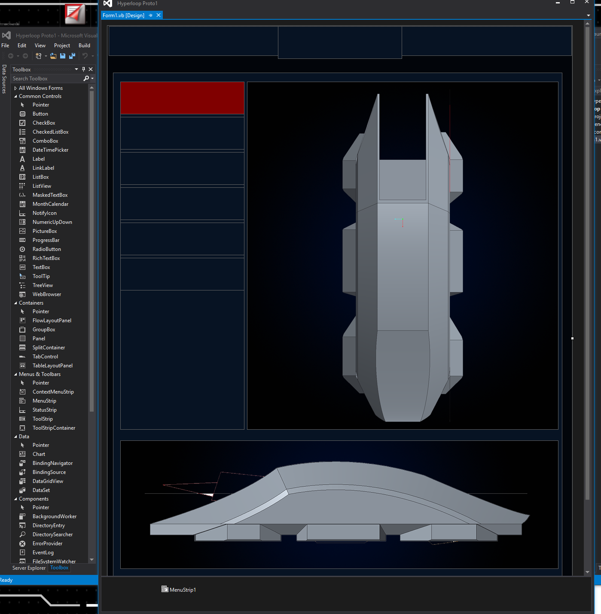­­

**\*Work in Progress**

## Control System

## C:\Users\harir\AppData\Local\Microsoft\Windows\INetCacheContent.Word\scheme1.png

## Network Programing

PC Server:

The TCP server code consist of 4 parts which includes Import References, connection establishment, send and receive. First the System.Net and System.Net.Socket is imported to declare the TCPServer as a Socket and a TCP Listener to listen for multiple incoming messages. The connection establishment is accomplished by clicking on the connect button which will start the TCP listener with the Host device IP address and the port number given in textbox. Once it is connected the picturebox will light green and you will be able to proceed to recieve or send messages. To send messages just enter a value into the Server_send textbox which will be sent by the TCP Server.send command taking the text box value as the argument to the Client. When Receiving messages from the clients the TCPserver.receive will keep listen to for messages constant as the function/event is called every timer interval which is set to 100ms and will allow the datastream to constantly take in data and sort through the data filter mention previously.

When Communicating between the Server and Client in this Network. We only need to start and stop the clock and photon when either timer is up or false start/fault is detected. In order to start the clock, the integer ‘1’ is send over to the photon but when we need to stop the clock or any process a ‘0’ will be send over to photon in which either case will comply. These was both implement into an initiate() and stop() function or into a switch case when the TCPServer.Send function/event was called which the integer will taken into the cases and sends out the intended command integer.

Photon Client:

The setup for the TCP server program as seen in the version 2.0 code is that the System.Net Reference is use to call the various event functions use to connect, send and receive by TCP. The TCP Client and TCPClientStream was declared as TCP Client for connection and Sockets.Network Stream for the data stream. The procedure for Connection establishment with the server is that first the connect button (button2) needs to be pressed where it will them Connect the TCP client with the IP Address and the port given by either hardwired or in this case an address and port value entered in the textbox given. Once it configures the address and the connection is indeed successful with the picture box lighting up green the Timer1_tick is enable for the Client to start Listening for data or messages sent from the server. The timer is again set to 100ms in order to constantly listen for the income messages.

To send the data simply press the hit button to send the hit detection integer (‘4’) to the server or simply input the value in send textbox and hit the click on the send button which will send the message over to the server. Again when sending or receiving between the server and client the byte stream is encoded to ASCII and then Decode when it is received on the other side. When sending sensitive data this needs to really be taking into consideration for data accuracy.

Photon TCP Client interface

In order to interface the Photon with the main hub of the system (Visual basic server application) the TCP protocol was used. The Photon configures itself with the correct parameters for TCP communication via Tcp Client C++ class. In order to send data Tcp Client: write(uint8_t) is called. This requirement was solved by writing data into an array of characters, figuring as a buffer.

## Microcontroller

A Microcontroller is an integrated device which performs a specific task according to the instructions stored in its memory. They are actually “computer on a chip”. Microcontrollers performed a sophisticated and critical role is this project as all the analogue inputs received from all the subsystems were processed by them. In this project we have chosen to use the Arduino Microcontroller for testing and prototyping purposes and finally we transferred to the Particle Photon. Although the great number of resources available for the Arduino influenced the solutions investigated in the first phase of the project, the outcome of our research confirmed that the Particle Photon was the right fit.

The Arduino:

The Arduino is an extremely efficient Microcontroller with an open source platform. It consists of both a physical programmable circuit board and an IDE (Integrated Development Environment) that runs on the computer. Figure 5.2.1.i shows an Arduino Uno which has been used in this project.

Figure 5.2.1.0: Arduino Uno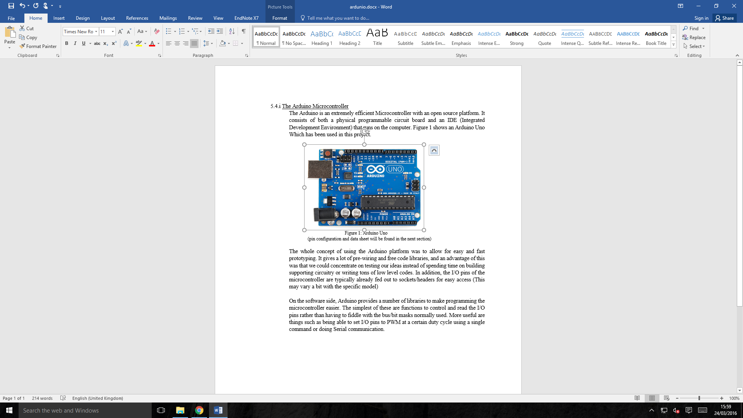

(pin configuration and data sheet will be found in the next section)

The whole concept of using the Arduino platform was to allow for easy and fast prototyping. It gives a lot of pre-wiring and free code libraries, and an advantage of this was that we could concentrate on testing our ideas instead of spending time on building supporting circuitry or writing tons of low level codes. In addition, the I/O pins of the microcontroller are typically already fed out to sockets/headers for easy access (This may vary a bit with the specific model).

On the software side, Arduino provides a number of libraries to make programming the microcontroller easier. The simplest of these are functions to control and read the I/O pins rather than having to fiddle with the bus/bit masks normally used. More useful are things such as being able to set I/O pins to PWM at a certain duty cycle using a single command or doing Serial communication.

The Photon

The Photon is not just powerful but also easy to use. It has the same capabilities as the arduino(i.e the I/O ports, libraries) with additional components like the Broadcom Wifi. It also has an open cloud services where the user can store collect data over the internet. Figure 5.2.1.ii shows the Photon.

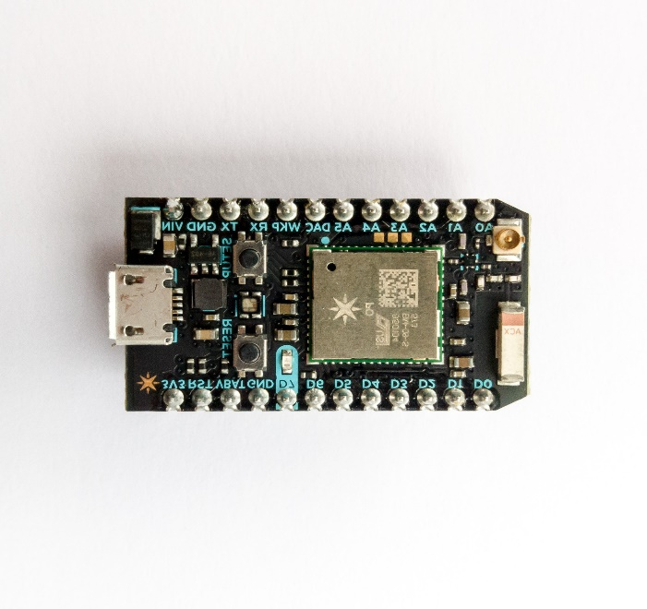

Figure 5.2.1 ii

The photon is used in this project due to its, size, portability and power consumption. So it can be easily integrated into the capsule. The data can be transmitted wirelessly using the Broadcom Wifi and so no excess wiring is required on the capsule or tube.

## CAD

## 3D Printing

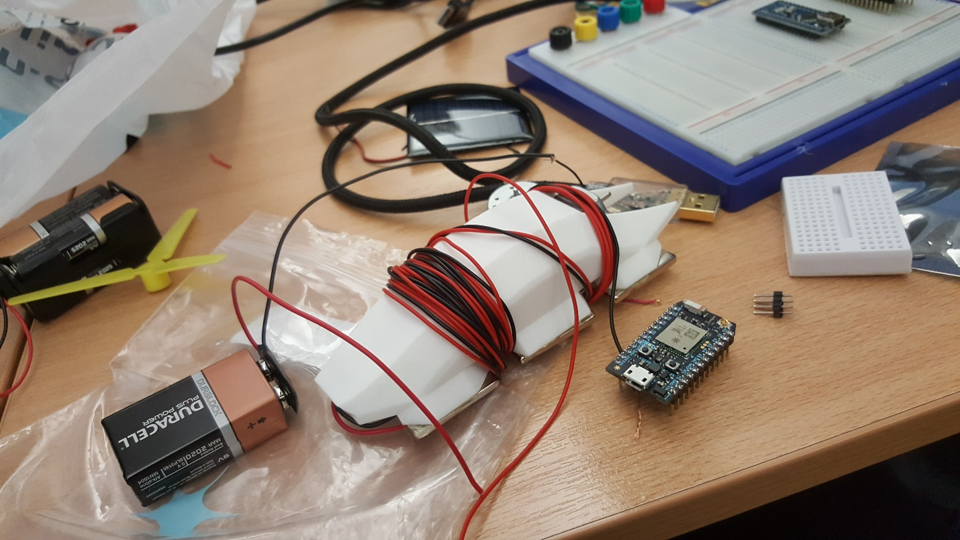

## Designs

## Design #1

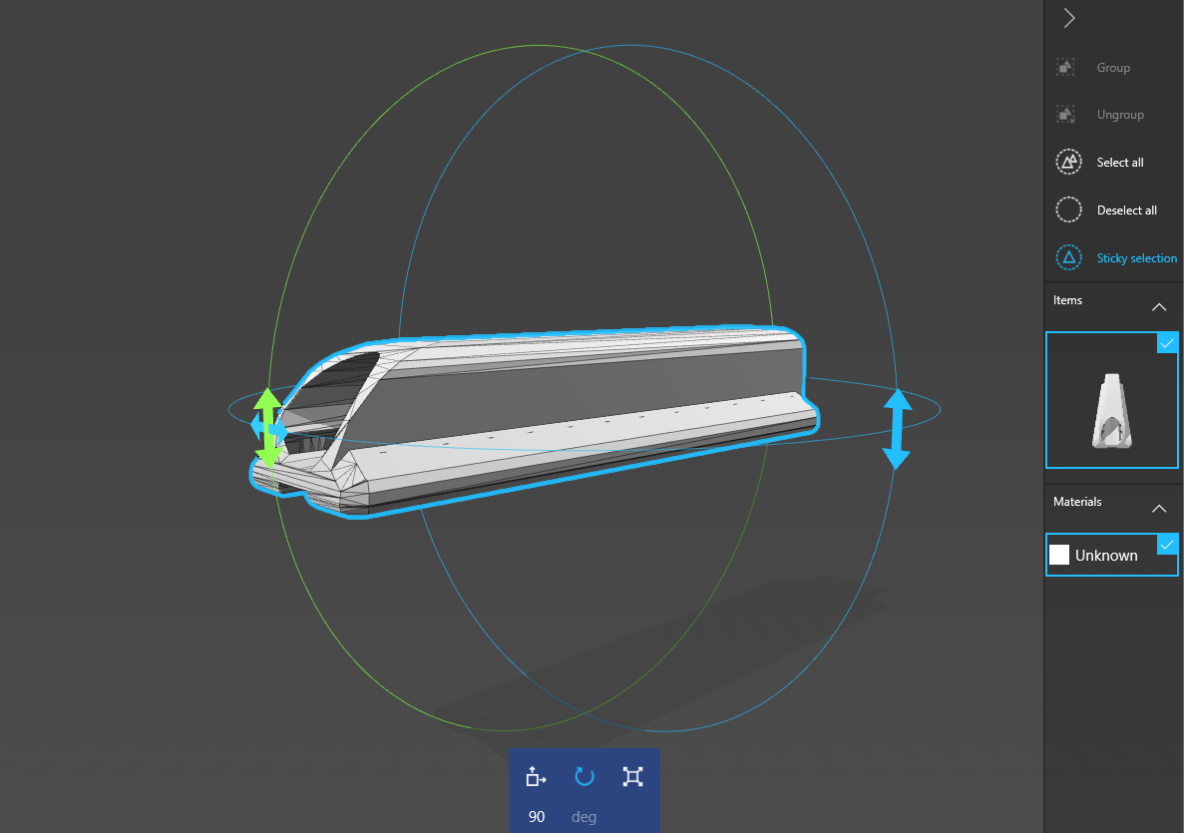

## Design #2

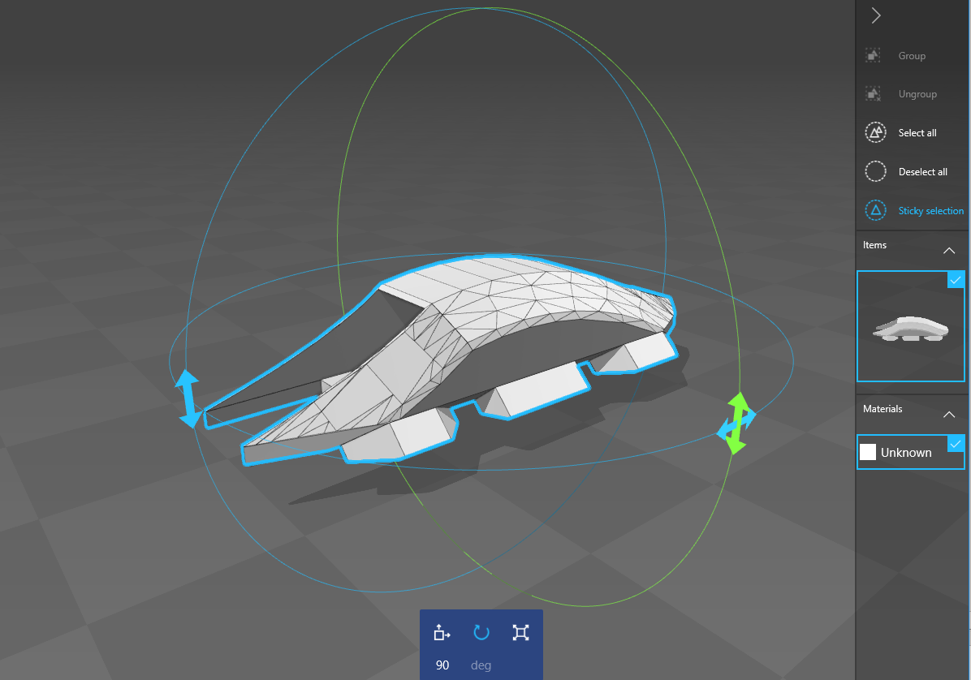

## Design #3

